import pandas as pd
import numpy as np
import seaborn as sns
import matplotlib.pyplot as plt
import warnings
warnings.filterwarnings(action="ignore")
from sklearn.model_selection import train_test_split
from sklearn.metrics import accuracy_score, classification_report
from sklearn.ensemble import AdaBoostClassifier
from sklearn.neural_network import BernoulliRBM
from sklearn.preprocessing import StandardScaler
from imblearn.over_sampling import SMOTE
import tensorflow as tf
from tensorflow.keras.models import Sequential
from tensorflow.keras.layers import Dense
from sklearn import metrics
from sklearn.metrics import confusion_matrix
from sklearn.datasets import make_classification
from sklearn.metrics import accuracy_score, precision_score, recall_score, f1_score
#importing data from the dataset
df = pd.read_csv(r"C:\Users\agarw\OneDrive\Desktop\Dissertation\data.csv")
#checking for bankrupt companies 0 is non-bankrupt and 1 is bankrupt
bankrupt_data = df['Bankrupt?'].value_counts()
bankrupt_data
0 6599
1 220
Name: Bankrupt?, dtype: int64
#Distribution representation
plt.figure(figsize = (10,5))
ax = sns.countplot(df['Bankrupt?'])
ax.bar_label(ax.containers[0])
plt.title('Class Distribution \n (0:Financially Stable || 1:Financially Unstable)', fontsize = 14)
plt.show()
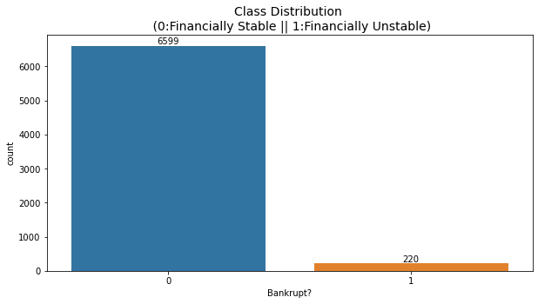
# seperate the Bankrupt label from the dataset
y = df['Bankrupt?']
X = df.drop(['Bankrupt?'], axis = 1)
# divinding our dataset into training dataset
X_train, X_temp, y_train, y_temp = train_test_split(X, y, test_size=0.2, random_state=42)
plt.figure(figsize = (10,5))
ax = sns.countplot(y_train)
ax.bar_label(ax.containers[0])
plt.title('Class Distribution \n (0:Financially Stable || 1:Financially Unstable)', fontsize = 14)
plt.show()
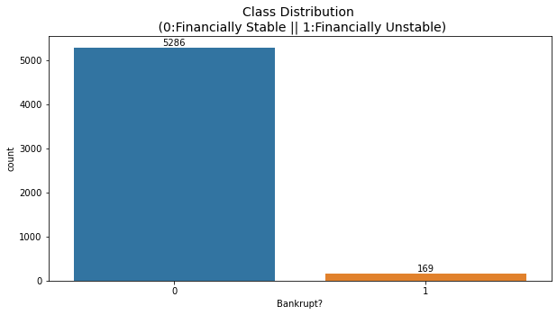
# divinding our dataset into testing and validation
X_val, X_test, y_val, y_test = train_test_split(X_temp, y_temp, test_size=0.5, random_state=42)
smote = SMOTE(sampling_strategy=1, random_state=42)
X_train_resampled, y_train_resampled = smote.fit_resample(X_train, y_train)
plt.figure(figsize = (10,5))
ax = sns.countplot(y_train_resampled)
ax.bar_label(ax.containers[0])
plt.title('Class Distribution \n (0:Financially Stable || 1:Financially Unstable)', fontsize = 14)
plt.show()
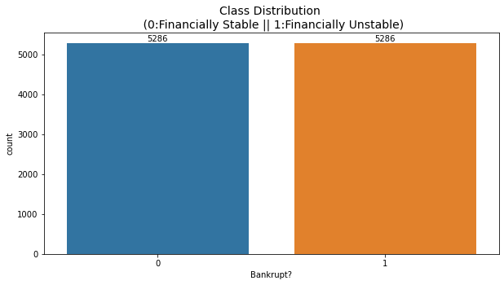
# Standardize the data
scaler = StandardScaler()
X_train_resampled = scaler.fit_transform(X_train_resampled)
X_val = scaler.transform(X_val)
X_test = scaler.transform(X_test)
rbm = BernoulliRBM(n_components=95, n_iter=10, random_state=42)
rbm.fit(X_train_resampled)
BernoulliRBM(n_components=95, random_state=42)
# Transform the data using the trained RBM
X_train_transformed = rbm.transform(X_train_resampled)
X_val_transformed = rbm.transform(X_val)
X_test_transformed = rbm.transform(X_test)
model = tf.keras.Sequential([
tf.keras.layers.Input(shape=(X_train_transformed.shape[1],)),
tf.keras.layers.Dense(64, activation='relu'),
tf.keras.layers.Dropout(0.2),
tf.keras.layers.Dense(32, activation='relu'),
tf.keras.layers.Dropout(0.2),
tf.keras.layers.Dense(1, activation='sigmoid')
])
model.compile(optimizer='adam', loss='binary_crossentropy', metrics=['accuracy'])
model.fit(X_train_transformed, y_train_resampled, epochs=50, batch_size=32, verbose=2)
Epoch 1/50
331/331 - 1s - loss: 0.4140 - accuracy: 0.8302 - 1s/epoch - 4ms/step
Epoch 2/50
331/331 - 0s - loss: 0.3879 - accuracy: 0.8396 - 348ms/epoch - 1ms/step
Epoch 3/50
331/331 - 0s - loss: 0.3805 - accuracy: 0.8431 - 352ms/epoch - 1ms/step
Epoch 4/50
331/331 - 0s - loss: 0.3760 - accuracy: 0.8418 - 344ms/epoch - 1ms/step
Epoch 5/50
331/331 - 0s - loss: 0.3751 - accuracy: 0.8458 - 339ms/epoch - 1ms/step
Epoch 6/50
331/331 - 0s - loss: 0.3757 - accuracy: 0.8432 - 343ms/epoch - 1ms/step
Epoch 7/50
331/331 - 0s - loss: 0.3768 - accuracy: 0.8415 - 346ms/epoch - 1ms/step
Epoch 8/50
331/331 - 0s - loss: 0.3724 - accuracy: 0.8437 - 338ms/epoch - 1ms/step
Epoch 9/50
331/331 - 0s - loss: 0.3726 - accuracy: 0.8410 - 341ms/epoch - 1ms/step
Epoch 10/50
331/331 - 0s - loss: 0.3716 - accuracy: 0.8451 - 348ms/epoch - 1ms/step
Epoch 11/50
331/331 - 0s - loss: 0.3718 - accuracy: 0.8443 - 350ms/epoch - 1ms/step
Epoch 12/50
331/331 - 0s - loss: 0.3710 - accuracy: 0.8425 - 357ms/epoch - 1ms/step
Epoch 13/50
331/331 - 0s - loss: 0.3725 - accuracy: 0.8428 - 353ms/epoch - 1ms/step
Epoch 14/50
331/331 - 0s - loss: 0.3732 - accuracy: 0.8431 - 340ms/epoch - 1ms/step
Epoch 15/50
331/331 - 0s - loss: 0.3716 - accuracy: 0.8443 - 351ms/epoch - 1ms/step
Epoch 16/50
331/331 - 0s - loss: 0.3715 - accuracy: 0.8453 - 340ms/epoch - 1ms/step
Epoch 17/50
331/331 - 0s - loss: 0.3708 - accuracy: 0.8452 - 339ms/epoch - 1ms/step
Epoch 18/50
331/331 - 0s - loss: 0.3713 - accuracy: 0.8450 - 366ms/epoch - 1ms/step
Epoch 19/50
331/331 - 0s - loss: 0.3706 - accuracy: 0.8435 - 339ms/epoch - 1ms/step
Epoch 20/50
331/331 - 0s - loss: 0.3674 - accuracy: 0.8459 - 342ms/epoch - 1ms/step
Epoch 21/50
331/331 - 0s - loss: 0.3672 - accuracy: 0.8442 - 346ms/epoch - 1ms/step
Epoch 22/50
331/331 - 0s - loss: 0.3667 - accuracy: 0.8456 - 336ms/epoch - 1ms/step
Epoch 23/50
331/331 - 0s - loss: 0.3650 - accuracy: 0.8448 - 342ms/epoch - 1ms/step
Epoch 24/50
331/331 - 0s - loss: 0.3712 - accuracy: 0.8449 - 364ms/epoch - 1ms/step
Epoch 25/50
331/331 - 0s - loss: 0.3672 - accuracy: 0.8457 - 343ms/epoch - 1ms/step
Epoch 26/50
331/331 - 0s - loss: 0.3693 - accuracy: 0.8471 - 343ms/epoch - 1ms/step
Epoch 27/50
331/331 - 0s - loss: 0.3689 - accuracy: 0.8449 - 352ms/epoch - 1ms/step
Epoch 28/50
331/331 - 0s - loss: 0.3669 - accuracy: 0.8445 - 345ms/epoch - 1ms/step
Epoch 29/50
331/331 - 0s - loss: 0.3710 - accuracy: 0.8458 - 344ms/epoch - 1ms/step
Epoch 30/50
331/331 - 0s - loss: 0.3682 - accuracy: 0.8462 - 360ms/epoch - 1ms/step
Epoch 31/50
331/331 - 0s - loss: 0.3688 - accuracy: 0.8448 - 340ms/epoch - 1ms/step
Epoch 32/50
331/331 - 0s - loss: 0.3687 - accuracy: 0.8457 - 343ms/epoch - 1ms/step
Epoch 33/50
331/331 - 0s - loss: 0.3671 - accuracy: 0.8446 - 348ms/epoch - 1ms/step
Epoch 34/50
331/331 - 0s - loss: 0.3698 - accuracy: 0.8456 - 340ms/epoch - 1ms/step
Epoch 35/50
331/331 - 0s - loss: 0.3663 - accuracy: 0.8468 - 341ms/epoch - 1ms/step
Epoch 36/50
331/331 - 0s - loss: 0.3677 - accuracy: 0.8452 - 370ms/epoch - 1ms/step
Epoch 37/50
331/331 - 0s - loss: 0.3663 - accuracy: 0.8455 - 344ms/epoch - 1ms/step
Epoch 38/50
331/331 - 0s - loss: 0.3681 - accuracy: 0.8455 - 344ms/epoch - 1ms/step
Epoch 39/50
331/331 - 0s - loss: 0.3674 - accuracy: 0.8478 - 348ms/epoch - 1ms/step
Epoch 40/50
331/331 - 0s - loss: 0.3685 - accuracy: 0.8447 - 368ms/epoch - 1ms/step
Epoch 41/50
331/331 - 0s - loss: 0.3673 - accuracy: 0.8447 - 349ms/epoch - 1ms/step
Epoch 42/50
331/331 - 0s - loss: 0.3671 - accuracy: 0.8461 - 381ms/epoch - 1ms/step
Epoch 43/50
331/331 - 0s - loss: 0.3671 - accuracy: 0.8454 - 408ms/epoch - 1ms/step
Epoch 44/50
331/331 - 0s - loss: 0.3686 - accuracy: 0.8454 - 402ms/epoch - 1ms/step
Epoch 45/50
331/331 - 0s - loss: 0.3705 - accuracy: 0.8420 - 377ms/epoch - 1ms/step
Epoch 46/50
331/331 - 0s - loss: 0.3667 - accuracy: 0.8472 - 366ms/epoch - 1ms/step
Epoch 47/50
331/331 - 0s - loss: 0.3678 - accuracy: 0.8472 - 374ms/epoch - 1ms/step
Epoch 48/50
331/331 - 0s - loss: 0.3662 - accuracy: 0.8442 - 372ms/epoch - 1ms/step
Epoch 49/50
331/331 - 0s - loss: 0.3670 - accuracy: 0.8453 - 383ms/epoch - 1ms/step
Epoch 50/50
331/331 - 0s - loss: 0.3669 - accuracy: 0.8475 - 365ms/epoch - 1ms/step
<keras.src.callbacks.History at 0x28c28bad880>
#Validation dataset
y_val_pred = (model.predict(X_val_transformed) > 0.5).astype(int)
22/22 [==============================] - 0s 897us/step
# Evaluate the model's performance on the validation set
val_accuracy = accuracy_score(y_val, y_val_pred)
precision = precision_score(y_val, y_val_pred)
recall = recall_score(y_val, y_val_pred)
f1_value = f1_score(y_val, y_val_pred)
val_report = classification_report(y_val, y_val_pred)
print("Accuracy", val_accuracy)
print("Precision", precision)
print("Recall", recall)
print("F1 Score", f1_value)
print("Validation Classification Report:\n", val_report)
Accuracy 0.8035190615835777
Precision 0.125
Recall 0.95
F1 Score 0.22093023255813954
Validation Classification Report:
precision recall f1-score support
0 1.00 0.80 0.89 662
1 0.12 0.95 0.22 20
accuracy 0.80 682
macro avg 0.56 0.87 0.55 682
weighted avg 0.97 0.80 0.87 682
conf_matrix = confusion_matrix(y_val, y_val_pred)
print("Confusion Matrix")
print(conf_matrix)
Confusion Matrix
[[529 133]
[ 1 19]]
y_test_pred = (model.predict(X_test_transformed) > 0.5).astype(int)
22/22 [==============================] - 0s 1ms/step
# Evaluate the model's performance on the test set
test_accuracy = accuracy_score(y_test, y_test_pred)
precision = precision_score(y_test, y_test_pred)
recall = recall_score(y_test, y_test_pred)
f1_value = f1_score(y_test, y_test_pred)
test_report = classification_report(y_test, y_test_pred)
print("Accuracy", test_accuracy)
print("Precision", precision)
print("Recall", recall)
print("F1 Score", f1_value)
print("Test Classification Report:\n", test_report)
Accuracy 0.8093841642228738
Precision 0.18064516129032257
Recall 0.9032258064516129
F1 Score 0.3010752688172043
Test Classification Report:
precision recall f1-score support
0 0.99 0.80 0.89 651
1 0.18 0.90 0.30 31
accuracy 0.81 682
macro avg 0.59 0.85 0.60 682
weighted avg 0.96 0.81 0.86 682
conf_matrix = confusion_matrix(y_val, y_test_pred)
print("Confusion Matrix")
print(conf_matrix)
Confusion Matrix
[[512 150]
[ 15 5]]

